Data Warehouse

# Introduction

A data warehouse is a centralized repository that stores, integrates, and manages large volumes of structured and unstructured data from various sources within an organization. It is designed to support business intelligence (BI) and analytics activities. There are several reasons why data warehouses are needed:

1. Data Integration: In organizations, data is typically scattered across various systems, departments, and databases. Data warehouses provide a unified view by integrating data from disparate sources, making it easier for analysts and decision-makers to access and analyze data in a consistent and coherent manner.
2. Historical Data Storage: Data warehouses retain historical data over extended periods, allowing businesses to track and analyze trends, patterns, and performance over time. This historical perspective enables better strategic planning and informed decision-making.
3. Improved Performance: Data warehouses are optimized for analytical queries rather than transactional processing. They employ techniques like indexing, partitioning, and aggregations to deliver faster query performance, enabling efficient analysis of large datasets.
4. Support for Complex Queries: Business analysts often need to perform complex queries that involve multiple tables and data transformations. Data warehouses facilitate such queries through the use of OLAP (Online Analytical Processing) and data modeling techniques.
5. Data Cleansing and Transformation: Data warehouses often incorporate an ETL (Extract, Transform, Load) process to clean, transform, and standardize data before loading it into the warehouse. This ensures data quality and consistency, reducing the risk of making decisions based on erroneous information.
6. Decision Support and Business Intelligence: Data warehouses are the foundation for business intelligence and decision support systems. They provide a platform for generating reports, dashboards, and data visualizations, enabling businesses to gain valuable insights and make data-driven decisions.

BI stands for Business Intelligence. It refers to the technologies, processes, and practices used by organizations to collect, integrate, analyze, and present business data and information. The primary goal of business intelligence is to support better decision-making and strategic planning within an organization.

1. Scalability: As data volumes grow, data warehouses can scale to accommodate the increased data storage and processing requirements, ensuring that the organization can handle expanding data needs effectively.
2. Data Security and Governance: Data warehouses often implement robust security measures to control data access and protect sensitive information. They also facilitate compliance with data governance and regulatory requirements.
3. Support for Different Data Types: Data warehouses can handle structured, semi-structured, and unstructured data, enabling organizations to analyze diverse data types, such as text, images, and multimedia.
4. Separation of Analytical Workloads: By using a data warehouse, analytical workloads can be separated from operational systems, preventing resource contention and ensuring that operational systems can perform their core functions efficiently.

# OLTP and OLAP

OLTP and OLAP are two different types of database systems, each serving distinct purposes in the realm of data processing and analytics:

1. OLTP (Online Transaction Processing): OLTP systems are designed to handle and manage operational transactions in real-time. They are commonly used for day-to-day business operations where large numbers of short and quick transactions take place. OLTP databases are optimized for rapid data insertions, updates, and deletions while ensuring data integrity. Some key characteristics of OLTP systems include:

* Low-latency: OLTP databases prioritize fast response times to support real-time transaction processing.
* Normalized Data: OLTP databases often use normalized data models to reduce redundancy and maintain data consistency, even if it means complex relationships between tables.
* Concurrent Users: OLTP systems are typically used by multiple users simultaneously, making concurrent access an essential requirement.
* Example Usage: E-commerce websites, banking systems, airline reservation systems, point-of-sale systems, etc.

1. OLAP (Online Analytical Processing): OLAP systems, on the other hand, are designed for complex data analysis and decision support. They facilitate the exploration of large volumes of historical and aggregated data to identify trends, patterns, and insights. OLAP databases are optimized for fast query performance and are well-suited for complex analytical operations such as data mining and multidimensional analysis. Some key characteristics of OLAP systems include:

* High-performance Analytics: OLAP databases use pre-aggregated and summarized data to enable fast analytical queries.
* Denormalized Data: OLAP databases often use denormalized or star/snowflake schema data models to optimize query performance and simplify data retrieval.
* Read-Only Access: OLAP systems are primarily used for reading data, as they are not typically involved in real-time transaction processing.
* Example Usage: Business intelligence tools, data warehouses, executive dashboards, decision support systems.

In summary, OLTP databases are optimized for transactional processing, supporting real-time data manipulation for day-to-day operations, while OLAP databases are optimized for analytical processing, facilitating complex data analysis and reporting to aid decision-making. Some organizations use both OLTP and OLAP systems in combination to create a comprehensive data infrastructure that supports both operational processes and business intelligence activities.

# Datalake

A data lake and a data warehouse are both large-scale data storage architectures used in modern data management, but they serve different purposes and have distinct characteristics. Let's explore the differences between a data lake and a data warehouse:

Data Lake:

1. Data Structure: A data lake is designed to store raw, unstructured, and structured data in its native format. This means that data in a data lake may not have a predefined schema or organization.
2. Data Ingestion: Data lakes can accept a wide variety of data types, including text, images, videos, logs, social media data, sensor data, and more. It allows for the storage of massive amounts of data from diverse sources without significant preprocessing.
3. Schema on Read: In a data lake, the data schema is applied when the data is read or queried, not when it is ingested. This schema-on-read approach provides greater flexibility and agility when dealing with diverse and rapidly changing data.
4. Storage: Data lakes typically use distributed file systems, such as Hadoop Distributed File System (HDFS) or cloud-based object storage, to store large volumes of data cost-effectively.
5. Data Processing: Data lakes often support various data processing and analytics tools like Apache Spark, Apache Hive, or Apache Hadoop, allowing data to be processed and transformed in place.

Data Warehouse:

1. Data Structure: A data warehouse is designed to store structured data that has been extracted, transformed, and loaded (ETL) from various sources. The data is organized in a predefined schema to facilitate querying and analysis.
2. Data Ingestion: Data warehouses follow a well-defined ETL process, where data is extracted from source systems, transformed to fit the warehouse's schema, and then loaded into the warehouse.
3. Schema on Write: Data warehouses enforce a rigid schema-on-write approach, where data must adhere to the predefined schema before it can be loaded into the warehouse.
4. Storage: Data warehouses use traditional relational database management systems (RDBMS) or columnar databases to store data efficiently in a structured manner.
5. Data Processing: Data warehouses are optimized for high-performance query processing and analytical operations. They support SQL-based queries and are well-suited for business intelligence and reporting purposes.

Main Differences:

* Data lakes are capable of storing both raw and processed data in its native form, while data warehouses store structured and processed data based on a predefined schema.
* Data lakes are ideal for storing vast amounts of diverse and unprocessed data, making them well-suited for exploratory data analysis and data science tasks.
* Data warehouses are designed to provide fast and efficient analytical querying for business intelligence and decision-making purposes.
* Data lakes are more flexible in accommodating new data sources and formats, while data warehouses require careful schema design before loading data.

# Layers of Data Warehouse

A data warehouse (DWH) typically consists of multiple layers that work together to organize and manage data effectively. These layers provide a structured approach to storing and processing data, making it accessible for analytical purposes. The common layers of a data warehouse are as follows:

1. Data Source Layer: This layer is where data originates and includes various sources such as operational databases, external data feeds, cloud services, spreadsheets, and more. The data source layer is responsible for extracting data from these heterogeneous sources.
2. Data Extraction Layer (ETL - Extract, Transform, Load): The ETL layer is responsible for extracting data from the data source layer, transforming it into a consistent and standardized format, and loading it into the data warehouse. This process involves data cleansing, data enrichment, data validation, and sometimes aggregating or summarizing the data.
3. Staging Area: The staging area serves as an intermediate storage location where the data extracted from the sources is temporarily stored before it undergoes the ETL process and is loaded into the data warehouse. It helps to ensure data integrity and allows for validation and auditing before data is moved to the next layer.
4. Data Storage Layer: The data storage layer is the core component of the data warehouse, where the transformed and cleaned data is stored in a structured and organized manner. Data warehouses typically use different data models, such as a star schema or snowflake schema, to store data in tables with dimensions and facts.
5. Data Presentation Layer: The presentation layer is responsible for making data accessible to end-users for querying and analysis. It includes tools like business intelligence (BI) reporting tools, dashboards, and data visualization software that allow users to explore and gain insights from the data stored in the data warehouse.
6. Data Access Layer: The data access layer manages the security and access controls for data within the data warehouse. It ensures that users only have access to the data they are authorized to view and that data privacy and security requirements are met.
7. Metadata Layer: The metadata layer contains information about the data in the data warehouse. It includes data definitions, data lineage, data relationships, and other metadata attributes. Metadata provides crucial documentation and context for understanding and managing the data in the data warehouse.
8. Operational Management Layer: This layer is responsible for monitoring and managing the overall health and performance of the data warehouse system. It includes tools for monitoring data loads, managing backups, and optimizing query performance to ensure the data warehouse operates efficiently.

# Data Marts

Data marts are subsets of a data warehouse that are designed to support specific business functions or departments within an organization. They are a logical partitioning of data from the main data warehouse, focusing on providing data that is relevant and tailored to the needs of a particular group of users.

Here are some key characteristics and benefits of data marts:

1. **Focused Data**: Data marts contain data that is specific to a particular business area, such as sales, marketing, finance, or human resources. This focused approach ensures that users in those departments can access the data they need without being overwhelmed by irrelevant information.
2. **Performance Optimization**: By creating data marts, organizations can improve query performance for users. Since data marts only contain a subset of data relevant to a specific department, queries run faster compared to querying the entire data warehouse.
3. **User Empowerment**: Data marts are often designed with the end-users' needs in mind. They provide users with a self-service environment, allowing them to access and analyze data independently using tools like business intelligence dashboards or reporting systems.
4. **Data Security**: Data marts can have separate access controls and security measures from the main data warehouse, providing an additional layer of data security. This ensures that users can only access the data they are authorized to view.
5. **Scalability**: Data marts can be designed to scale independently. As the organization's needs grow, new data marts can be created or existing ones expanded to accommodate additional data and users.
6. **Departmental Autonomy**: Data marts can offer departments a level of autonomy in managing their data. Departments can define their data models and business rules independently, as long as they adhere to the overall data warehouse's guidelines.
7. **Flexibility**: Data marts can be built using different data models, such as star schema or snowflake schema, based on the specific requirements of the business function they serve. This flexibility allows for tailored data structures that align with user needs.

# In Memory Database

An in-memory database (IMDB) is a type of database management system (DBMS) that stores data primarily in the main memory (RAM) of a computer, rather than on traditional disk storage. In-memory databases are designed to provide extremely fast data access and retrieval times, making them ideal for applications that require real-time processing and low-latency responses.

Here are some key characteristics and benefits of in-memory databases:

1. **Faster Performance**: The primary advantage of in-memory databases is their speed. Since data is stored and accessed directly in RAM, read and write operations are significantly faster compared to disk-based databases. This makes in-memory databases ideal for applications that require rapid data access and real-time analytics.
2. **Real-time Analytics**: In-memory databases are well-suited for real-time data processing and analytics, allowing businesses to gain immediate insights from their data without the delay associated with disk I/O.
3. **Reduced Latency**: In-memory databases dramatically reduce data access latency, leading to improved application responsiveness and better user experience.
4. **High Throughput**: In-memory databases can handle a high volume of concurrent read and write operations, making them suitable for applications with heavy transactional workloads.
5. **Simplified Data Structures**: In-memory databases often use simplified data structures, such as key-value stores or columnar storage, to optimize data access and minimize memory usage.
6. **No Disk I/O Bottleneck**: In traditional disk-based databases, disk I/O can become a bottleneck, limiting the overall performance. In-memory databases eliminate this bottleneck since data is not stored on disk.
7. **Real-time Decision-making**: With fast data access and processing, in-memory databases enable businesses to make real-time decisions based on the most current data available.
8. **Data Persistence**: While in-memory databases primarily store data in RAM, many of them offer options for data persistence, allowing data to be stored on disk for durability and recovery purposes.
9. **High Scalability**: In-memory databases can scale horizontally and vertically to accommodate increasing data volumes and user concurrency.

In-memory databases are commonly used in various applications, including:

* High-frequency trading systems that require low-latency data processing.
* Real-time analytics platforms for instant insights into business data.
* Online transactional systems where quick response times are crucial.
* Caching layers to improve the performance of web applications.
* IoT (Internet of Things) applications, where real-time data processing is essential.

It's important to note that in-memory databases, due to their reliance on RAM, may have higher memory requirements compared to disk-based databases. As a result, the cost of memory can be a consideration when implementing an in-memory database solution. Additionally, data in memory is volatile and can be lost in the event of a system crash or power failure, which is why many in-memory databases offer data persistence mechanisms to safeguard data in case of unexpected failures.

# Cube

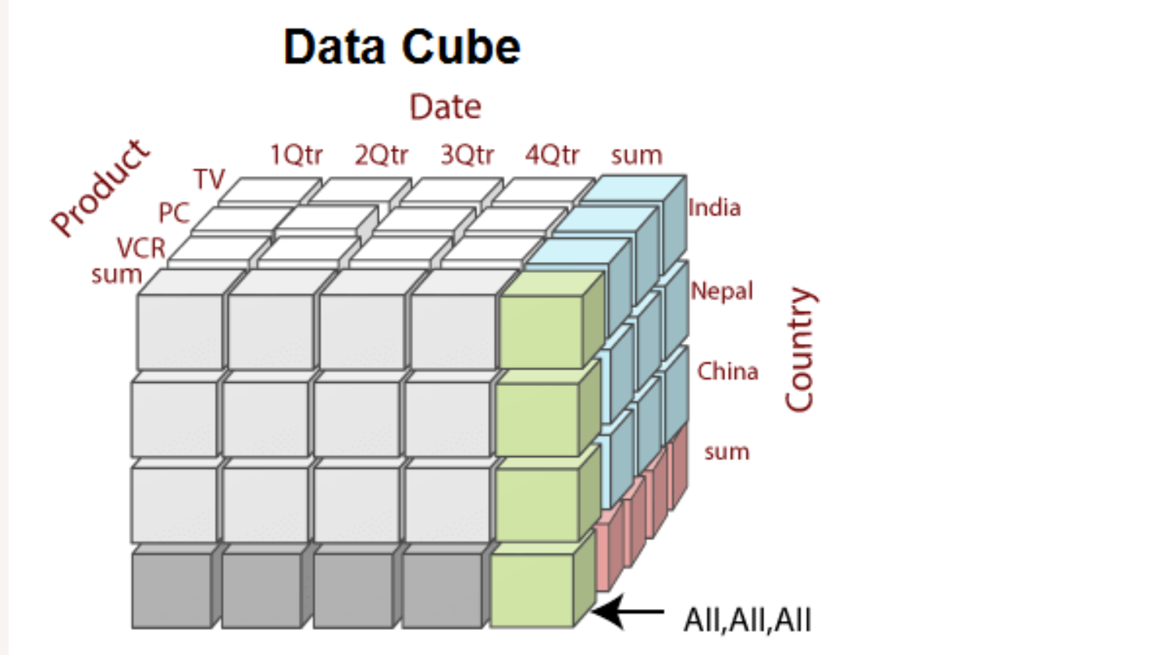

In the context of databases and data analysis, a cube refers to a multidimensional data structure used in Online Analytical Processing (OLAP). OLAP cubes are designed to facilitate complex data analysis and reporting by organizing data into multiple dimensions, allowing users to explore data from different perspectives easily. The term "cube" is used because the data can be conceptualized as forming a cube with multiple dimensions.

Let's explore the key features and components of an OLAP cube:

1. **Dimensions**: Dimensions represent the different attributes or characteristics along which data is analyzed. Each dimension provides a unique perspective on the data. For example, in a sales cube, dimensions could include time, products, regions, and customers.
2. **Measures**: Measures, also known as facts, are the numerical values that users want to analyze. They represent the data points in the cube and can be aggregated for different combinations of dimensions. Examples of measures in a sales cube include sales revenue, quantity sold, and profit.
3. **Hierarchies**: Dimensions often have hierarchical relationships. For instance, the "Time" dimension may have levels like year, quarter, month, and day. Hierarchies allow users to drill down into more detailed data or roll up to higher-level summaries.
4. **Cuboid**: A cuboid is a specific combination of dimensions in the OLAP cube. It represents a unique subcube of data. For example, a cuboid might represent sales data for a particular product category in a specific region during a specific time period.
5. **Slicing, Dicing, and Pivoting**: OLAP cubes enable slicing (selecting a single value along one dimension), dicing (selecting a subcube by specifying values along multiple dimensions), and pivoting (reorienting the cube to view data from a different perspective). These operations allow users to explore data in various ways and gain insights from different angles.
6. **Aggregation**: OLAP cubes store pre-aggregated data at different levels of granularity. This allows for faster query response times when summarizing large datasets, as the calculations are already performed during data processing and storage.
7. **OLAP Server**: The OLAP server is the software component responsible for managing and processing OLAP cubes. It provides a query interface for users to interact with the cube, perform analysis, and retrieve data.

Let's illustrate the concept of OLAP cubes with a simple example of a sales cube. Consider a hypothetical retail company that sells products in different regions over time. The OLAP cube will have dimensions such as "Time," "Products," and "Regions," and measures such as "Sales Revenue" and "Quantity Sold."

1. **Dimensions**:
   * Time Dimension: Year → Quarter → Month → Day
   * Products Dimension: Product Category → Product Subcategory → Product Name
   * Regions Dimension: Country → State → City
2. **Measures**:
   * Sales Revenue
   * Quantity Sold
3. **Hierarchies**:
   * Time Dimension:
     + Year → Quarter → Month → Day
   * Products Dimension:
     + Product Category → Product Subcategory → Product Name
   * Regions Dimension:
     + Country → State → City

Now, let's create a sample cuboid representing sales data for the "Electronics" category, in the "United States," for the "Year 2023." We will use the measures "Sales Revenue" and "Quantity Sold" to represent the data in the cube.

Sample Cuboid:

* Time Dimension: Year 2023
* Products Dimension: Electronics (Product Category)
* Regions Dimension: United States (Country)

Measures:

* Sales Revenue: $1,000,000
* Quantity Sold: 2,500 units

In this cuboid, we have summarized the sales data for electronics products sold in the United States during the year 2023. Now, let's demonstrate some typical OLAP cube operations:

1. **Slicing**: Slicing involves selecting a single value along one dimension. For example, if we slice the cuboid by selecting the "Year 2023" from the "Time" dimension, we will see all the sales data for electronics products in the United States aggregated for the entire year 2023.
2. **Dicing**: Dicing involves selecting a subcube by specifying values along multiple dimensions. For example, if we dice the cuboid by selecting "Electronics" from the "Products" dimension and "California" from the "Regions" dimension, we will see all the sales data for electronics products in California, regardless of the year.
3. **Pivoting**: Pivoting involves reorienting the cube to view data from a different perspective. For example, we can pivot the cuboid to show sales data grouped by quarters instead of products, allowing us to analyze the sales performance of different product categories over each quarter in the United States during the year 2023.

# MOLAP and ROLAP

ROLAP (Relational Online Analytical Processing) and MOLAP (Multidimensional Online Analytical Processing) are two different approaches used in building Online Analytical Processing (OLAP) systems. They represent different ways to organize and store data to support analytical queries and reporting. Let's explore the characteristics and differences between ROLAP and MOLAP:

1. **ROLAP (Relational Online Analytical Processing)**:
   * Data Storage: ROLAP systems store data in traditional relational databases, such as SQL databases. Data is stored in tables and normalized structures.
   * Aggregation: ROLAP systems rely on on-the-fly aggregation and computation of measures during query execution. Aggregates are not precomputed and are calculated dynamically from the relational data at the time of querying.
   * Flexibility: ROLAP provides more flexibility in handling complex data relationships and large datasets as it leverages the power of relational databases.
   * Performance: ROLAP systems might experience slower query response times compared to MOLAP systems, especially for complex queries and large datasets, as aggregations are computed on the fly.
2. **MOLAP (Multidimensional Online Analytical Processing)**:
   * Data Storage: MOLAP systems use specialized multidimensional databases optimized for analytical queries. Data is organized in a pre-aggregated, multi-dimensional cube format.
   * Aggregation: MOLAP systems precompute and store aggregations for various dimensions and measures in the multidimensional cube. This allows for faster query response times, as the results are readily available without recalculating aggregates during query execution.
   * Storage Efficiency: MOLAP cubes can provide better storage efficiency for aggregated data since aggregations are precomputed and stored in a compressed format.
   * Performance: MOLAP systems generally offer faster query performance, especially for complex queries, as the aggregations are precomputed and stored in the cube.
3. **Usage Scenarios**:
   * ROLAP is suitable for scenarios where data is large, complex, and frequently changing, as it can leverage the power and flexibility of relational databases to handle such data structures effectively.
   * MOLAP is suitable for scenarios where fast query performance is crucial, and data volumes can be managed effectively in a multidimensional cube. It is particularly useful for scenarios where ad-hoc analytical queries are common, and real-time aggregations are not required.
4. **Examples**:
   * Popular ROLAP implementations include Microsoft SQL Server Analysis Services (SSAS) using ROLAP storage mode and Oracle OLAP.
   * Popular MOLAP implementations include Microsoft SQL Server Analysis Services (SSAS) using MOLAP storage mode and IBM Cognos TM1.

# Operational Data Source

ODS stands for Operational Data Store. It is an intermediate database that serves as a bridge between operational systems and data warehouses or data marts. The primary purpose of an ODS is to capture and store current and integrated operational data from multiple sources, making it readily available for querying and reporting purposes.

Here are some key characteristics and functions of an Operational Data Store:

1. **Real-Time or Near-Real-Time Data**: ODS is designed to receive and store operational data in real-time or with minimal latency. It is capable of capturing data from various transactional systems as soon as it becomes available.
2. **Data Integration**: An ODS integrates data from multiple operational systems, such as transactional databases, applications, and external data sources. It acts as a central repository for this integrated data, providing a unified view.
3. **Data Transformation**: ODS may perform minimal data transformation, cleansing, and validation to ensure data quality and consistency. However, it typically retains data in its native format to minimize processing overhead.
4. **Data Reconciliation**: An ODS can perform data reconciliation to resolve data discrepancies and inconsistencies between different source systems. This ensures that the data is accurate and reliable before being loaded into the data warehouse.
5. **Operational Reporting**: ODS enables operational reporting and monitoring, allowing users to access near-real-time data for monitoring business processes and operations.
6. **Data Temporalization**: ODS may store historical snapshots of data to track changes over time, providing a temporal view of operational data.
7. **Limited Historical Data**: Unlike a data warehouse that retains historical data over extended periods, an ODS typically stores a limited window of historical data relevant to operational reporting and decision-making.
8. **Data Subset for Analytics**: An ODS may act as a subset or pre-aggregation of data from the operational systems, providing a more targeted and focused dataset for analytical purposes.
9. **Data Propagation**: Data from the ODS can be further processed and propagated to the data warehouse or data marts for deeper historical analysis, data modeling, and business intelligence reporting.

# Dimensional Modelling

Dimensional modeling is a data modeling technique used in designing data warehouses and data marts. It is specifically tailored to support Online Analytical Processing (OLAP) and business intelligence (BI) activities. The primary goal of dimensional modeling is to provide a user-friendly and efficient structure for querying and analyzing data, making it easier for business users to understand and navigate the data.

Key principles and components of dimensional modeling include:

## Fact Tables

The central component of dimensional modeling is the fact table. Fact tables store the quantitative, numeric data or measures of a business process. Examples of measures can include sales revenue, quantity sold, profit, etc. Each row in the fact table represents a specific event or transaction, and each cell contains a numeric value representing a measure.

### Additivity

Additivity in fact tables refers to the property that allows measures (numeric data) in the fact table to be aggregated or summarized correctly across different dimensions. In other words, the measures in the fact table should be able to be added, averaged, or aggregated in a meaningful way regardless of how the data is sliced or grouped by different dimensions.

The additivity property is crucial in dimensional modeling and data warehousing because it ensures the consistency of analytical results when performing queries and generating reports. When measures are additive, users can trust that aggregations and calculations performed on the data will yield accurate and meaningful results.

There are three common types of additivity for measures in fact tables:

1. **Additive**: Measures are additive if they can be directly added together across all dimensions. For example, sales revenue, quantity sold, and profit are additive measures. When querying across different dimensions, summing these measures will give meaningful results.
2. **Semi-additive**: Measures are semi-additive if they can be added across some dimensions but not all. For example, the measure "Inventory Quantity" is semi-additive because adding the inventory quantities for different products or regions might not provide a meaningful result. Instead, the inventory quantity should be looked at on a specific date or time period.
3. **Non-additive**: Measures are non-additive if they cannot be added together across any dimension. For example, the measure "Average Temperature" is non-additive because calculating the average temperature for different regions or time periods doesn't make sense. Non-additive measures require special handling, such as calculating weighted averages or using specific aggregation functions.

### Handling Nulls

Handling NULLs in a fact table is an important consideration in data modeling and database design. NULL values in a fact table can occur when there is missing or unknown data for certain measures in specific scenarios. Properly managing NULLs is essential to ensure accurate query results and meaningful data analysis. Here are some common approaches for dealing with NULLs in fact tables:

1. **Default Values**: For measures where data is missing, you can use default values to represent the NULLs. For example, if a sales transaction is missing a sales quantity, you can use a default value of zero to indicate that there were no sales for that particular entry.
2. **Unknown Values**: In some cases, NULLs may represent "unknown" data rather than missing data. You can assign a specific value, such as "-1" or "N/A," to represent unknown values. This approach differentiates between missing data and data that is known to have an undefined value.
3. **Zero vs. NULL**: Consider the difference between zero and NULL values. In some scenarios, NULL may imply that the data is genuinely missing, while zero may indicate a valid data point. It's crucial to use the appropriate value based on the context of the measure.
4. **Handling Aggregations**: When aggregating data in the fact table, it's essential to handle NULLs appropriately. Aggregating NULL values might lead to incorrect results. For example, if you sum sales revenue and some values are NULL, the total sum will not be accurate. One approach is to exclude NULL values from aggregations to get meaningful results.
5. **Use Special Flags**: You can use special flags or codes to indicate NULL values explicitly. For instance, you can use a flag like "UNKNOWN" or "N/A" to identify missing or unknown data in the fact table.
6. **Separate NULL and Non-NULL Columns**: In some cases, if a measure frequently has NULL values, you might consider storing NULL and non-NULL values in separate columns to improve query performance and optimize storage. This approach is more common in data warehouses where data is denormalized.
7. **Data Quality and Data Cleansing**: Ensuring data quality and thorough data cleansing processes can help minimize NULLs in the fact table. Regularly validating and cleaning the data can improve the completeness and accuracy of the data.

### Types of Fact Tables

1. **Transaction Fact Table**: This is the most basic type of fact table and is often used to capture individual transactions or events. Each row in the table represents a single transaction, and the fact table contains measures that are directly related to the transaction, such as sales revenue, quantity sold, or cost.
2. **Snapshot Fact Table**: Snapshot fact tables capture a snapshot of data at a specific point in time, usually at regular intervals (e.g., daily, weekly, or monthly). These tables are useful for tracking historical changes over time and are often associated with data that changes relatively infrequently, such as inventory levels or customer balances.
3. **Cumulative Fact Table**: A cumulative fact table stores cumulative values for a measure over time. This type of fact table is helpful for analyzing running totals or aggregations, such as cumulative sales revenue or cumulative profits.
4. **Aggregated Fact Table**: Aggregated fact tables store pre-aggregated values of measures to improve query performance. Instead of storing individual transaction-level data, these tables contain aggregated values for specific dimensions or combinations of dimensions. Aggregated fact tables are useful for quickly retrieving summarized data without the need for complex aggregations.
5. **Factless Fact Table**: A factless fact table contains no measures, only foreign keys to dimension tables. It is used to represent relationships between dimensions when there are no measurable facts to record. Factless fact tables are useful for tracking events or occurrences, such as student attendance or website clicks, where no specific measures are associated.
6. **Budget Fact Table**: Budget fact tables store planned or budgeted values for measures. They are useful for comparing actual performance against budgeted amounts to analyze budget variances and performance deviations.
7. **Derived Fact Table**: Derived fact tables contain calculated measures that are derived from other measures in the fact table. These calculated measures provide additional insights into the data and are computed based on specific business rules or formulas.

## Dimension Tables

Dimension tables provide descriptive attributes for the data in the fact table. They contain textual or categorical data that define the context of the measures in the fact table. Examples of dimensions can include time, products, customers, geography, etc. Dimension tables typically have a one-to-many relationship with the fact table.

### Types of Dimensions

1. **Slowly Changing Dimensions (SCD)**: Slowly Changing Dimensions are dimension tables that track historical changes in the data over time. There are three types of SCDs:
   * Type 1: Overwrites the existing data with the new data, losing historical information.
   * Type 2: Adds a new row for each change, preserving historical data and creating a surrogate key to track versions.
   * Type 3: Adds new columns to store limited historical data while maintaining the original value.
2. **Conformed Dimensions**: These dimensions are shared and used across multiple fact tables in the data warehouse. Conformed dimensions ensure consistency and uniformity in reporting and analysis.
3. **Junk Dimensions**: Junk dimensions combine multiple low-cardinality flags or attributes into a single dimension table. This helps reduce the number of dimension tables and simplify the schema, especially when dealing with many Boolean or flag-like attributes.
4. **Role-Playing Dimensions**: Role-playing dimensions are the same dimension used in multiple ways in the same fact table. For example, a date dimension might be used to represent both the order date and the ship date.
5. **Hierarchy Dimensions**: These dimensions have a hierarchical structure with various levels of detail. They are useful for drilling down or rolling up data for different levels of aggregation.
6. **Degenerate Dimensions**: Degenerate dimensions are attributes that are part of the fact table rather than a separate dimension table. They are typically used for transactional identifiers like order numbers or invoice numbers.
7. **Time Dimensions**: Time dimensions are a specific type of dimension table that represents time-related attributes, such as dates, months, quarters, and years. They are particularly important in time-based analyses.
8. **Geographic Dimensions**: Geographic dimensions provide information about geographic locations, such as countries, states, cities, and zip codes. They are useful when analyzing data based on geographical criteria.
9. **Customer Dimensions**: Customer dimensions store descriptive information about customers, such as names, addresses, contact details, and demographics.
10. **Product Dimensions**: Product dimensions contain details about products or services, such as names, categories, prices, and attributes.

## Star Schema

The most common dimensional modeling schema is the star schema. In a star schema, the fact table is at the center, and dimension tables radiate out from it, resembling a star shape. This structure simplifies data querying and allows for faster performance in analytical queries.

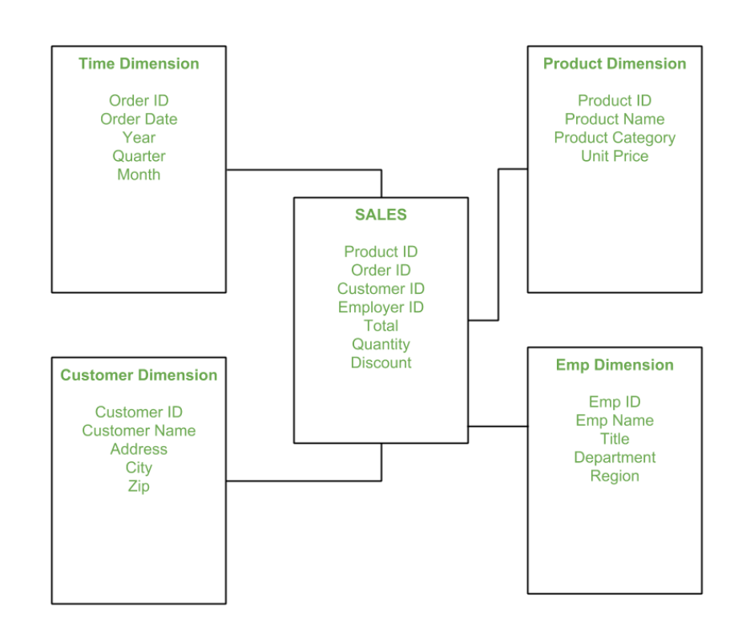

## Snowflake Schema

Another variation of the dimensional model is the snowflake schema. It is an extension of the star schema where dimension tables are normalized into multiple related tables. While it reduces data redundancy, it can make queries slightly more complex compared to the star schema.

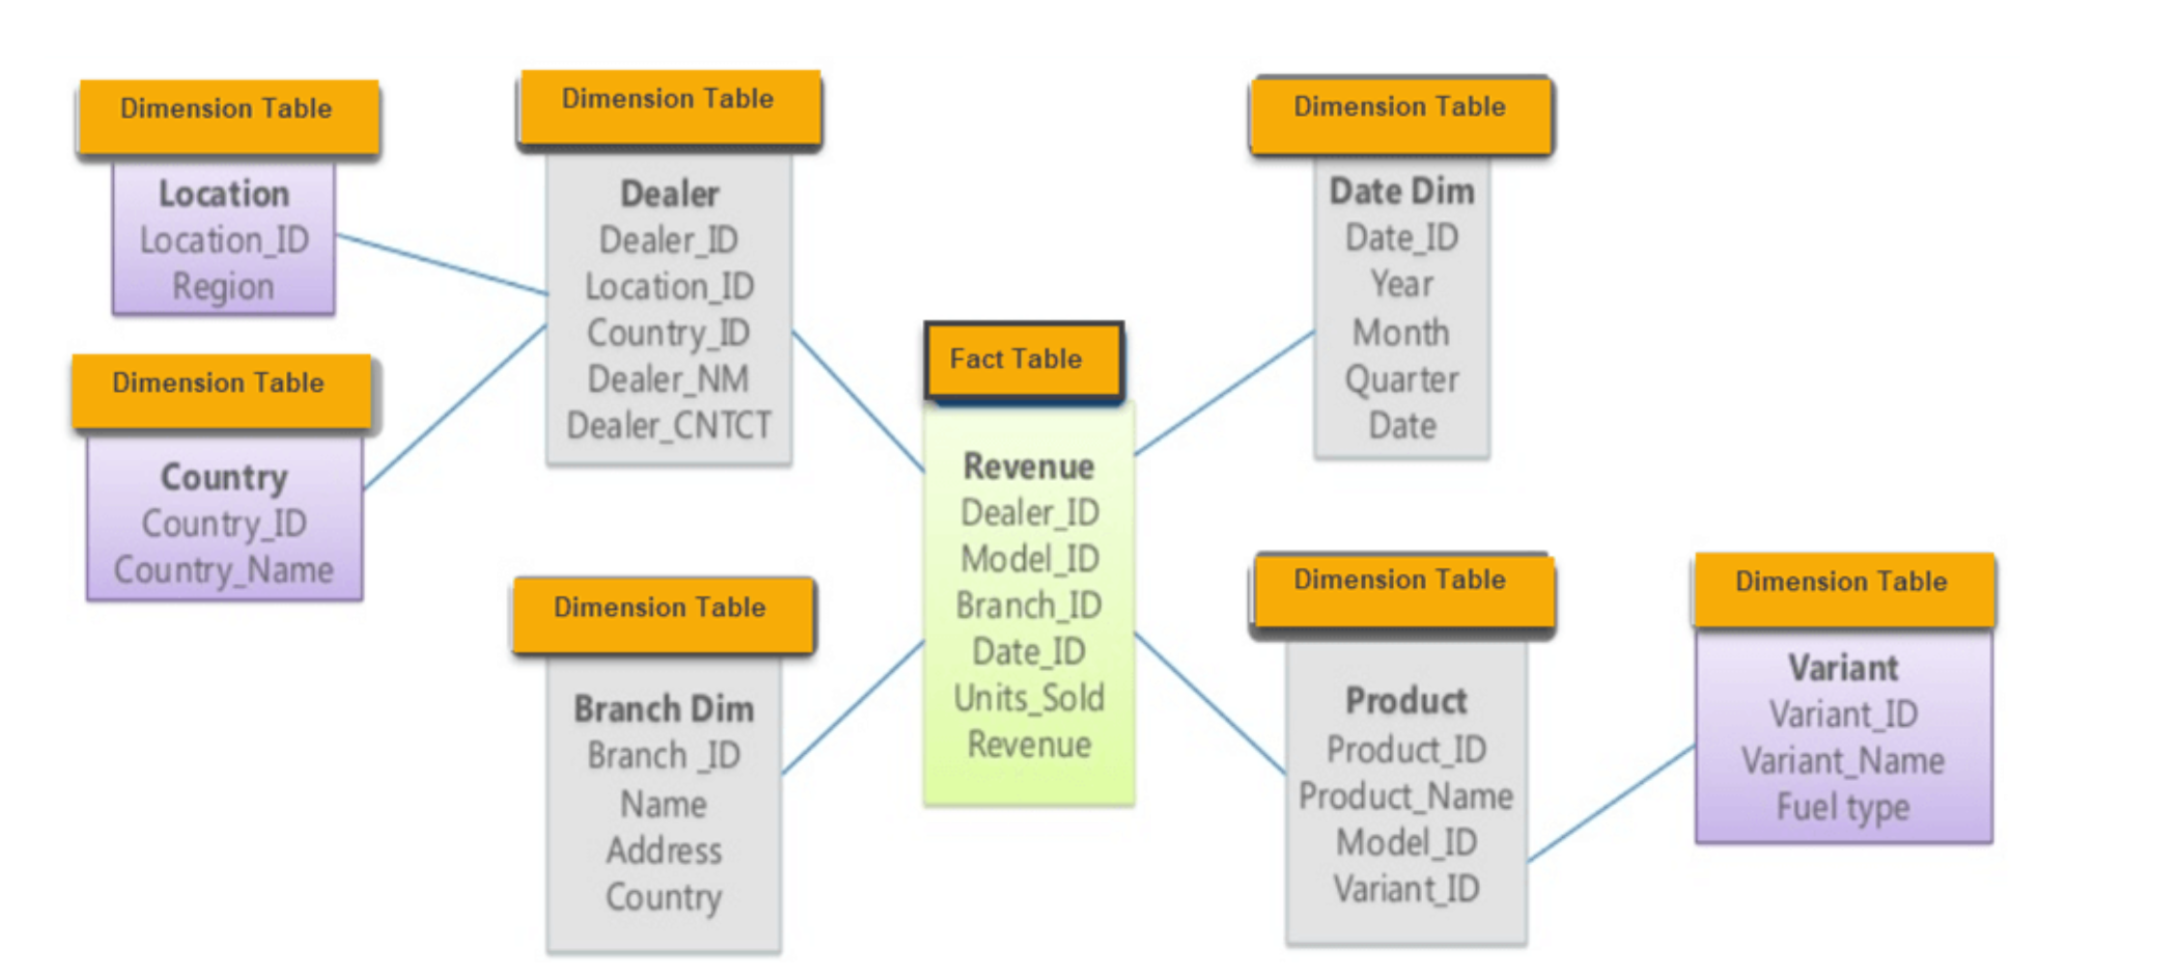

## Slowly Changing Dimensions (SCD)

Dimensional modeling also addresses the handling of changes in dimension attributes over time. Slowly Changing Dimensions (SCD) techniques are used to track historical changes and maintain historical context for measures.

1. **Degenerate Dimensions**: Degenerate dimensions are attributes that exist in the fact table instead of having a separate dimension table. They represent simple textual or numerical data that do not require complex dimensional hierarchies.
2. **Dimension Hierarchies**: Dimensional modeling allows for the creation of hierarchies within dimensions. Hierarchies provide a drill-down path to analyze data at different levels of granularity, such as year → quarter → month → day in the time dimension.

## Advantages of Dimensional Modeling

* Simplified Data Model: Dimensional modeling creates a clear and intuitive structure, making it easier for business users to understand and navigate the data.
* Fast Query Performance: Star schema and snowflake schema structures enable efficient and faster query performance, improving the response time for analytical queries.
* Flexibility: Dimensional models are flexible and can adapt to changing business requirements without significant disruptions to the data model.
* Support for Business Intelligence: Dimensional models are well-suited for supporting business intelligence and reporting activities, enabling users to gain insights from data with ease.

# ETL Process

In a Data Warehouse (DWH) environment, ETL (Extract, Transform, Load) refers to the process of extracting data from various sources, transforming it into a consistent and usable format, and loading it into the Data Warehouse for analysis, reporting, and business intelligence purposes. The ETL process is a fundamental step in building and maintaining a Data Warehouse, as it ensures that the data is accurate, consistent, and aligned with the business requirements. Let's take a closer look at each stage of the ETL process in the context of a Data Warehouse:

## Extract:

The first step of the ETL process is to extract data from different source systems. These source systems could include relational databases, transactional systems, spreadsheets, flat files, APIs, or even external data providers.

The extraction process involves identifying the relevant data to be extracted based on predefined criteria or queries.

Data can be extracted in full (a complete refresh) or incrementally (only new or modified data since the last extraction) to reduce the load on the source systems and improve efficiency.

#### Types of Data Load

**a. Initial Load**:

* The initial load, also known as the full load, is the first step in populating the Data Warehouse with data. It is the process of loading all the historical data from the source systems into the Data Warehouse for the first time.
* During the initial load, the ETL process extracts all relevant data from the source systems and transforms it into a consistent format suitable for the Data Warehouse schema.
* The initial load is typically a one-time process or may be executed periodically if the entire Data Warehouse needs to be refreshed or rebuilt due to major changes in the data model or structure.

**b. Delta Load**:

* After the initial load, subsequent data updates are typically handled through the delta load, which involves loading only the changes or new data since the last load.
* The delta load process identifies and extracts only the data that has been modified or added since the last load, reducing the amount of data processed compared to a full load.
* Delta loads are essential to keep the Data Warehouse up-to-date without reloading the entire dataset, which can be time-consuming and resource-intensive.

Summary:

To load:

1. Append row to table

2. Update data

3. Delete: Normally not deleted, just a flag added

## Transform

* Once the data is extracted, it undergoes a series of transformations to convert it into a consistent and usable format for the Data Warehouse.
* Data transformation involves various operations, such as data cleansing (removing duplicates, correcting errors), data enrichment (adding calculated fields, data lookups), data aggregation, data formatting, and data standardization.
* During this stage, data from different sources is harmonized and integrated to ensure uniformity and consistency across the Data Warehouse.

## Load

* After the data is extracted and transformed, it is loaded into the Data Warehouse. This step involves populating the appropriate tables within the Data Warehouse or Data Marts (a subset of the Data Warehouse focused on specific business functions or departments).
* The loading process may involve inserting new data, updating existing data (for slowly changing dimensions), or handling data deletion and archival.
* The loading process must be carefully managed to maintain data integrity and to handle any potential errors or issues during the transformation and loading process.

The ETL process is often automated using specialized ETL tools or data integration platforms to streamline the workflow, increase efficiency, and ensure data accuracy. These tools provide functionalities for data extraction, transformation, and loading, as well as scheduling and monitoring capabilities.

The ETL process is iterative and continuous, as the Data Warehouse requires regular updates to reflect the latest information from the source systems. Regular ETL cycles help to keep the Data Warehouse up-to-date, enabling users to access relevant and current data for their analytical and reporting needs.

## ETL Tools

* Enterprise – Better support, commercial
* Open Source – Often free
* Cloud Native tools
* Custom tools built by companies

Choosing the right tool: Consider cost, connectors,ease of use, reviews, support/extras.

## ETL vs ELT

1. **ETL (Extract, Transform, Load)**:
   * In the traditional ETL process, data is first extracted from various source systems.
   * After the extraction, the data is transformed into a consistent and usable format to align with the data warehouse schema and business requirements.
   * Finally, the transformed data is loaded into the data warehouse or data mart.

Advantages of ETL:

* + Data is cleaned, validated, and transformed before being loaded into the Data Warehouse, which can lead to a more refined and consistent dataset.
  + Transformation logic is applied during the ETL process, reducing the load on the Data Warehouse during the querying phase.

Disadvantages of ETL:

* + ETL processes can be resource-intensive and time-consuming, especially for large datasets, as the transformation is done before loading the data.
  + The ETL server requires sufficient processing power and storage to handle the data transformation.

1. **ELT (Extract, Load, Transform)**:
   * In the ELT process, data is first extracted from various source systems, similar to the ETL process.
   * Instead of transforming the data before loading, the data is directly loaded into the data warehouse in its raw form.
   * Once the data is loaded into the data warehouse, the transformation step is performed within the data warehouse itself using the processing power and capabilities of the data warehouse environment.

Advantages of ELT:

* + ELT processes can leverage the parallel processing capabilities of modern data warehouses, making it more scalable and efficient for large datasets.
  + Raw data is stored in the data warehouse, allowing for flexible and iterative transformations based on different business needs and scenarios.

Disadvantages of ELT:

* + ELT may result in data redundancy and complexity in the data warehouse, as raw data is stored alongside transformed data.
  + Transformation logic might need to be re-implemented in the data warehouse, potentially leading to duplicated effort.

# Use of DWH

1. Basis of Reporting

2. To analyse data

3. Predictive Analysis

4. Use BigData

5. For PowerBI

# Optimize DWH

Optimizing a Data Warehouse (DWH) using indexes can significantly improve query performance and reduce response times. Indexes are data structures that allow the database management system to quickly locate the rows that satisfy specific search conditions. In the context of a Data Warehouse, two common types of indexes are B-tree indexes and Bitmap indexes. Let's explore how each index type can be used to optimize a Data Warehouse:

1. **B-Tree Indexes**:

* B-tree indexes are commonly used in traditional relational database systems, including Data Warehouses.
* They are most effective for columns that have high cardinality, meaning columns with many distinct values, such as primary keys or frequently used filter columns.
* B-tree indexes are well-suited for range queries, such as queries that involve date ranges, and equality searches.
* When a B-tree index is created on a column, it organizes the data in a balanced tree structure, which allows for efficient data retrieval using logarithmic time complexity.

How to use B-Tree Indexes for optimization:

* Identify columns with high cardinality and those frequently used in WHERE clauses for filtering or joins.
* Create B-tree indexes on these columns to speed up query processing.
* Avoid creating B-tree indexes on low-cardinality columns or columns that are not frequently used in search conditions, as they may not provide significant performance improvements and can increase storage overhead.

1. **Bitmap Indexes**:

* Bitmap indexes are well-suited for columns with low cardinality, meaning columns with a limited number of distinct values, such as categorical or boolean fields.
* They work by creating a bitmap for each unique value in the indexed column, where each bit in the bitmap corresponds to a row in the table. The bit is set to 1 if the row matches the indexed value and 0 if it does not.
* Bitmap indexes are highly efficient for filtering on multiple criteria simultaneously using bitwise operations.
* They can be very effective for decision support queries and analytical workloads often encountered in Data Warehouses.

How to use Bitmap Indexes for optimization:

* Identify columns with low cardinality that are frequently used for filtering or in combination with other filter criteria.
* Create Bitmap indexes on these columns, especially when dealing with complex queries involving multiple filter conditions or joins.
* Bitmap indexes are space-efficient and are particularly beneficial for data warehouses with limited storage resources.

# Modern Data Warehouse

Modern Data Warehouses (DWHs) have evolved significantly with advancements in technology and computing paradigms. Let's compare some key aspects of modern DWHs, including their deployment models (cloud vs. on-premises), MPP (Massively Parallel Processing) architecture, and columnar storage.

## Deployment Model: Cloud vs. On-Premises

1. Cloud Data Warehouses: Cloud-based DWHs are hosted and managed by cloud service providers, such as Amazon Web Services (AWS), Microsoft Azure, or Google Cloud Platform (GCP). They offer a fully managed service, which means the provider handles infrastructure provisioning, scaling, maintenance, and backups. Cloud DWHs are flexible, scalable, and can rapidly provision resources based on demand. They also allow for easier integration with other cloud services and tools.
2. On-Premises Data Warehouses: On-premises DWHs are deployed and managed within an organization's own data center. Companies have complete control over their infrastructure and data, but this requires more significant upfront capital investment and ongoing maintenance and updates.

## MPP (Massively Parallel Processing) Architecture

MPP Data Warehouses: MPP architecture is a critical feature of modern Data Warehouses, both in the cloud and on-premises. MPP systems distribute data and processing across multiple nodes or servers, allowing for parallel execution of queries. This parallel processing capability enables high-performance data retrieval and analysis, particularly for complex analytical queries involving large datasets.

## Columnar Storage

Columnar Data Storage: Modern Data Warehouses often use columnar storage, where data is organized and stored in columns rather than rows. This storage format offers several advantages, including better compression, reduced I/O, and improved query performance. Since analytical queries typically access a subset of columns rather than all columns in a row, columnar storage can significantly speed up query processing.